**Total Variation denoising filter :**

1. **Read our images and convert it into floating point value :**

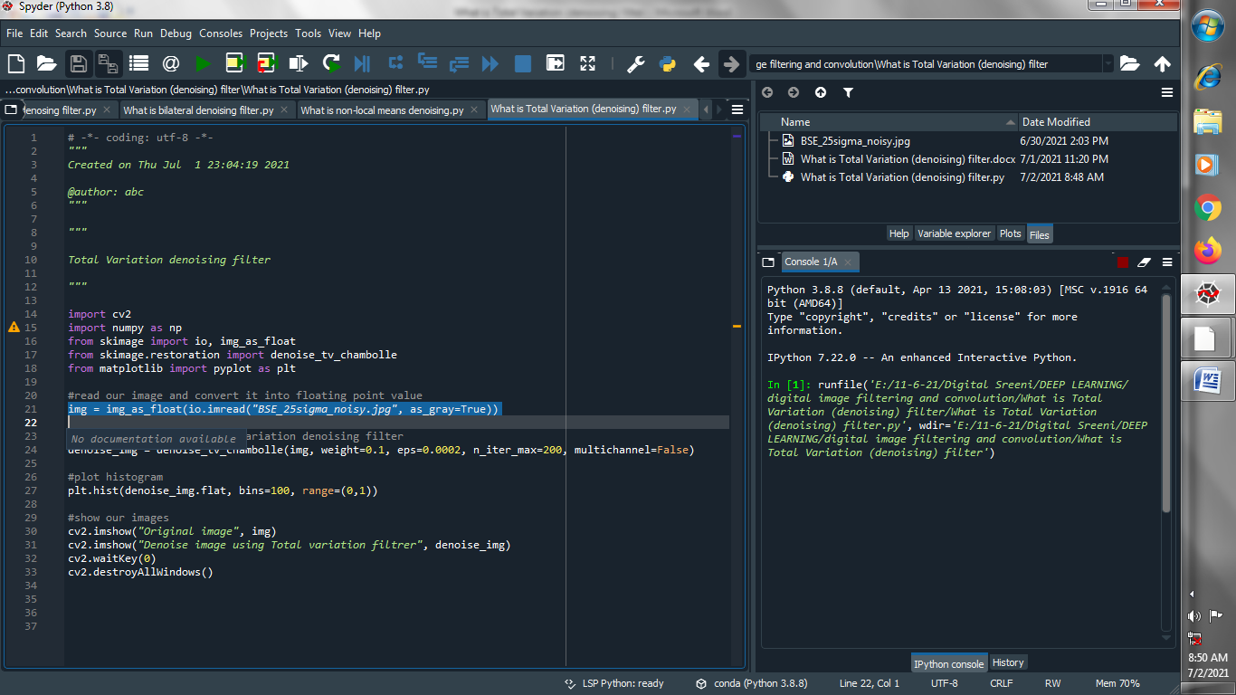

1. **Denoise image using total variation filter :**

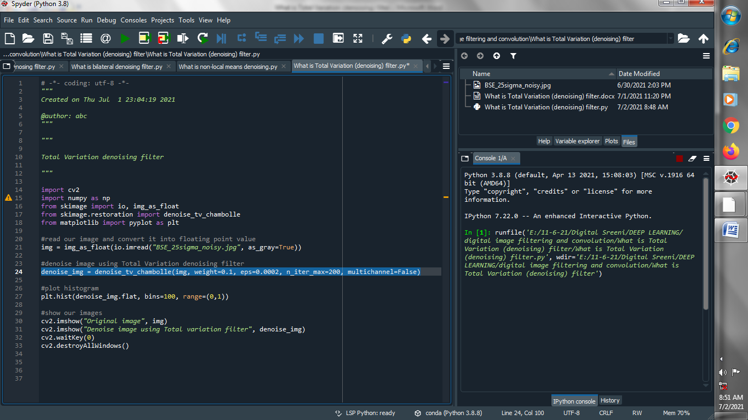

1. **Plot histogram :**

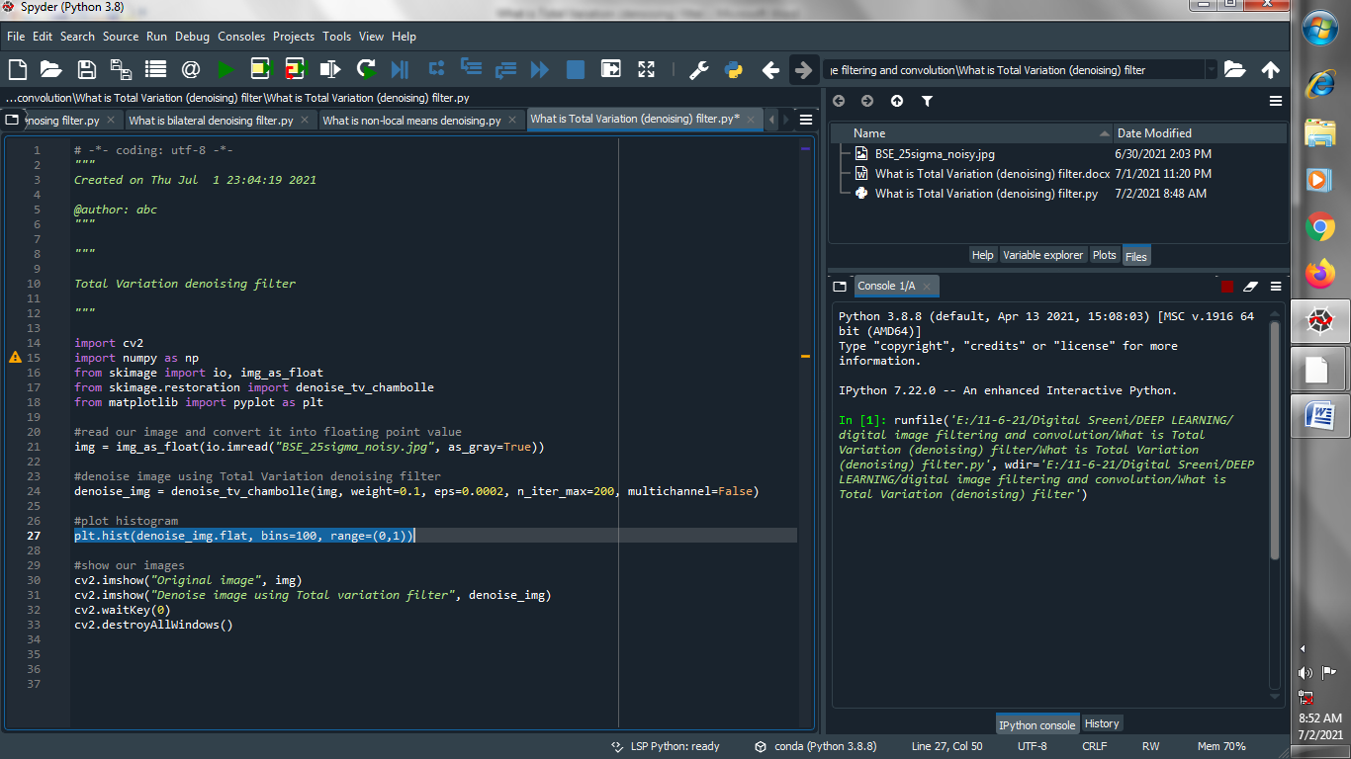

1. **Show our images :**

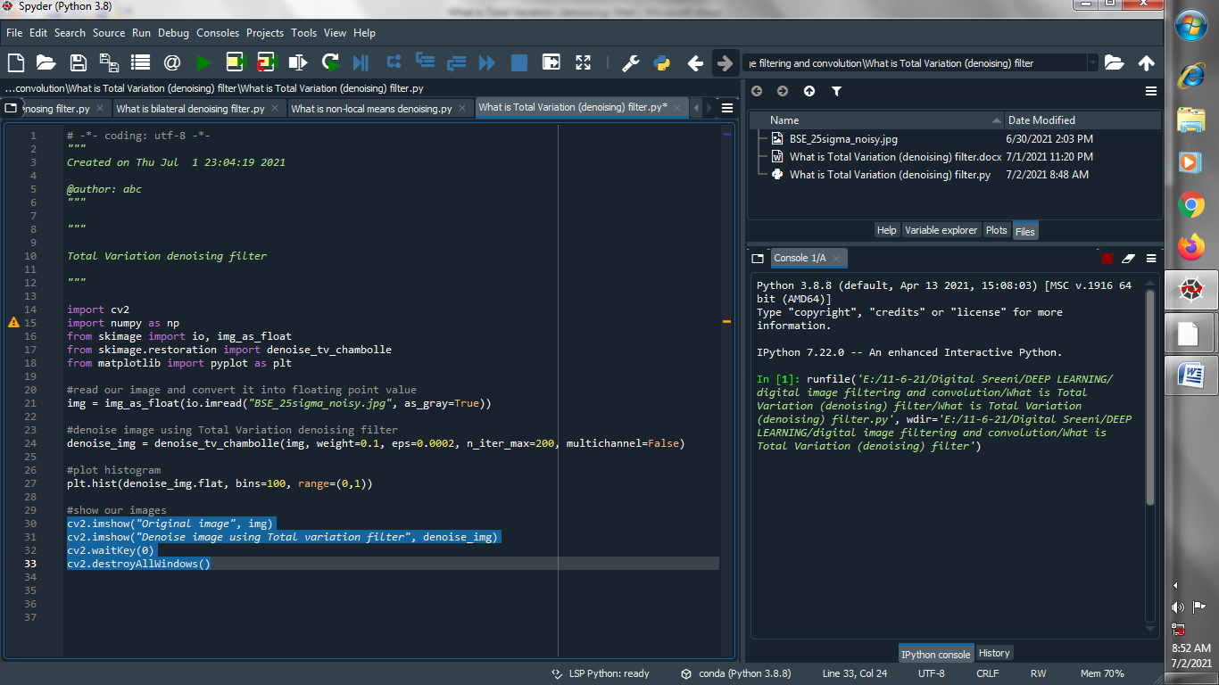

**Output :**

**Original image :**

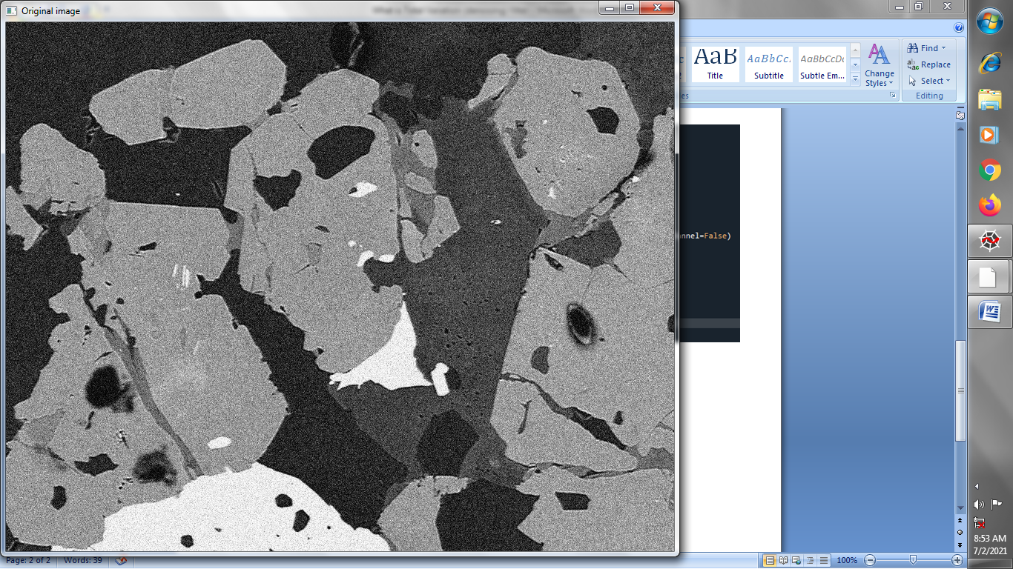

**Denoising image using Total-Variation filter :**

